**\*\*\*\*\*\*\*\*\*\*\*\*\*\*\*\*\*\*\*\*\*\*\*\*\*Kafka\*\*\*\*\*\*\*\*\*\*\*\*\*\*\*\*\*\*\*\*\*\*\*\*\*\*\*\*\*\*\*\***

**\*\*\*\*\*\*\*\*\*\*\*\*\*\*\*\*\*\*Kafka-Installation\*\*\*\*\*\*\*\*\*\*\*\*\*\*\*\*\*\*\*\*\*\*\*\*\***

1)Create kafka-logs and zookeeper folder in kafka installation directory and specify that path in the zookeeper.properties and server.properties file. As follows.

********************* zookeeper.properties ******************

# the directory where the snapshot is stored.

#dataDir=/tmp/zookeeper

dataDir=C:/kafka/zookeeper

********************* server.properties ******************

# A comma separated list of directories under which to store log files-

#log.dirs=/tmp/kafka-logs

log.dirs=C:/kafka/kafka-logs

**\*\*\*\*\*\*\*\*\*\*\*\*\*\*\*\*\*\*\*\*\*\*\*\*\*\*\*\*\*\*\*x\*\*\*\*\*\*\*\*\*\*\*\*\*\*\*\*\*\*\*\*\*\*\*\*\*\***

You can create server1.proerties or server2 properties depending on no of brokers you want to create on different port number. Broker should have unique id with unique port number

**\*\*\*\*\*\*\*\*\*\*\*\*\*\*\*\*\*\*\*\*\*\*\*\*\*\*\*\*\*\*\*\*\*Start Zookeeper server\*\*\*\*\*\*\*\*\*\*\*\*\*\*\*\*\*\*\*\***

C:\kafka> .\bin\windows\zookeeper-server-start.bat .\config\zookeeper.properties

**\*\*\*\*\*\*\*\*\*\*\*\*\*\*\*\*\*\*\*\*\*\*\*\*\*\*\*\*\*Start Kafka server\*\*\*\*\*\*\*\*\*\*\*\*\*\*\*\*\***

C:\kafka> .\bin\windows\kafka-server-start.bat .\config\server.properties

**\*\*\*\*\*\*\*\*\*\*\*\*\*\*\*\*\*\*Create Topics\*\*\*\*\*\*\*\*\*\*\*\*\*\*\*\*\*\*\*\*\*\*\*\*\*\*\***

C:\kafka> .\bin\windows\kafka-topics.bat --create --zookeeper localhost:2181 --replication-factor 2 --partitions 3 -topic MovieTopic

WARNING: Due to limitations in metric names, topics with a period ('.') or underscore ('_') could collide. To avoid issues it is best to use either, but not both.

Created topic MovieTopic.

**\*\*\*\*\*\*\*\*\*\*\*\*\*\*\*\*\*\*\*\*\*\*\*\*Check Topic is created or not\*\*\*\*\*\*\*\*\*\*\*\*\*\*\*\*\***

C:\kafka> .\bin\windows\kafka-topics.bat --list --zookeeper localhost:2181

CgMovieTopics

MovieTopic

MovieTopic1

Movie_Topic

__consumer_offsets

**\*\*\*\*\*\*\*\*\*\*\*\*\*\*\*\*\*\*\*\*\*\*\*\*\*\*\*\*\*Consume from Kafka using groups\*\*\*\*\*\*\*\*\*\*\*\*\*\*\*\***

## Consume from the Kafka Topic via Console

C:\kafka> .\bin\windows\kafka-console-consumer.bat --bootstrap-server localhost:9092 --topic MovieTopic --from-beginning --group vaishaligroup1

**\*\*\*\*\*\*\*\*\*\*\*\*\*\*Produce the messages using producer console\*\*\*\*\*\*\*\*\*\*\*\*\*\***

C:\kafka> .\bin\windows\kafka-console-producer.bat --broker-list localhost:9092 –topic MovieTopic

>Hello all

>how r u

**\*\*\*\*\*\*\*\*\*\*\*\*\*\*\*\*\*\*\*\*\*Produce the message in the topics which is not existing\*\***

C:\kafka> .\bin\windows\kafka-console-producer.bat --broker-list localhost:9092 -topic MovieTopic1

>hi

[2021-07-29 17:15:17,988] WARN [Producer clientId=console-producer] Error while fetching metadata with correlation id 3 : {MovieTopic1=LEADER_NOT_AVAILABLE} (org.apache.kafka.clients.NetworkClient)

>

**\*\*\*\*\*\*\*\*\*\*\*\*\*\*\*\*\*\*\*\*\*\*\*Describe topics\*\*\*\*\*\*\*\*\*\*\*\*\*\*\*\*\*\*\*\*\*\*\*\*\*\*\*\***

C:\kafka> .\bin\windows\kafka-topics.bat --describe --zookeeper localhost:2181 --topic MovieTopic

Topic: MovieTopic TopicId: 8vrLwhUSTC6PSlN3i4sU5Q PartitionCount: 3 ReplicationFactor: 1 Configs:

Topic: MovieTopic Partition: 0 Leader: 0 Replicas: 0 Isr: 0

Topic: MovieTopic Partition: 1 Leader: 0 Replicas: 0 Isr: 0

Topic: MovieTopic Partition: 2 Leader: 0 Replicas: 0 Isr: 0

**\*\*\*\*\*\*\*\*\*\*\*\*\*\*\*\*\*\*\*\*\*\*\*\*\*\*\*\*\*\*\*Delete Topic\*\*\*\*\*\*\*\*\*\*\*\*\*\*\*\*\*\*\*\*\*\*\*\***

C:\kafka>.\bin\windows\kafka-topics.bat --delete --zookeeper localhost:2181 -topic Movie_Topic

Topic Movie_Topic is marked for deletion.

Note: This will have no impact if delete.topic.enable is not set to true.

**\*\*\*\*\*\*\*\*\*\*\*\*\*\*\*\*\*\*\*\*Installation Kafka End\*\*\*\*\*\*\*\*\*\*\*\*\*\*\*\*\*\*\*\*\*\***

**\*\*\*\*\*\*\*\*\*\*\*\*\*\*\*\*\*\*\*\*\*\*\*X\*\*\*\*\*\*\*\*\*\*\*\*\*\*\*\*\*\*\*\*\*\*\*\*\*\*\*\*\*\*\*\*\*\*\*\*\***

**What do we learn in Kafka?**

**Ans-**

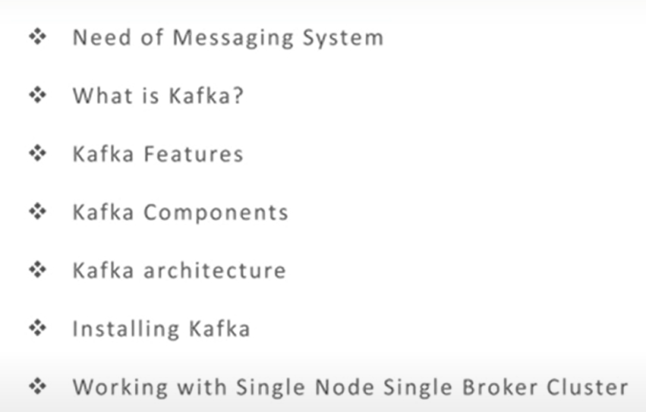

**-----------------------------------------X---------------------------------------------------------------**

**Why do we need Messaging System?**

**Ans-**

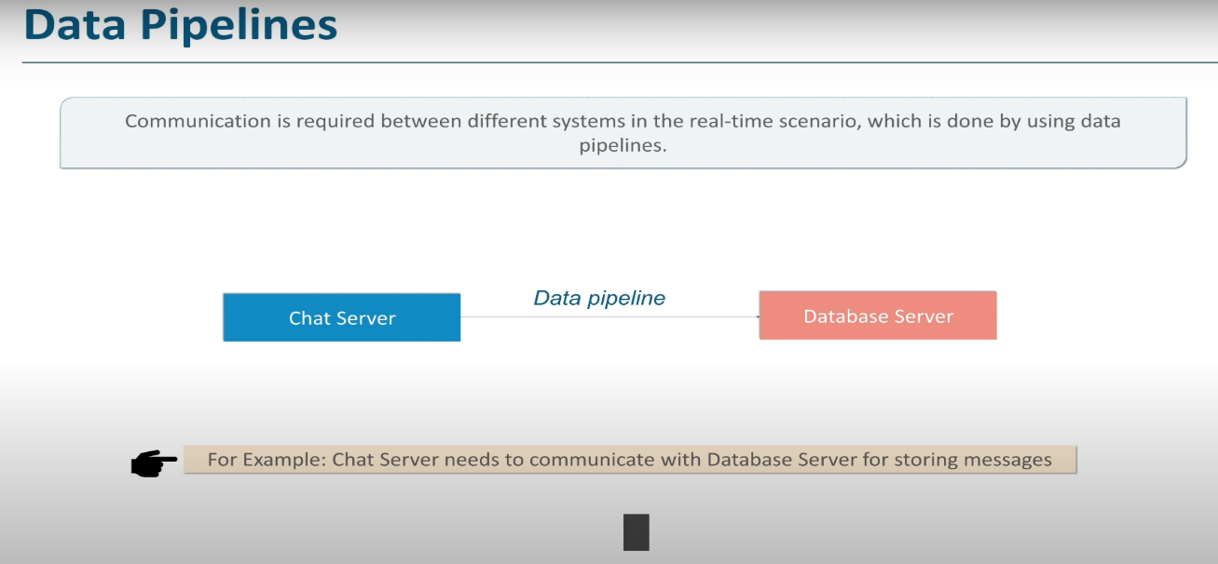

* There can be either mail server, FTP server, SMTP server, database server ,application server, web server.
* Now a day’s organization cannot survive with 2-3 server for their application like.
* Complex ecommerce’s application will have many types of server in front end which will communicate with backend application as follows.
* In that scenario application Data Pipeline become complex as follows.

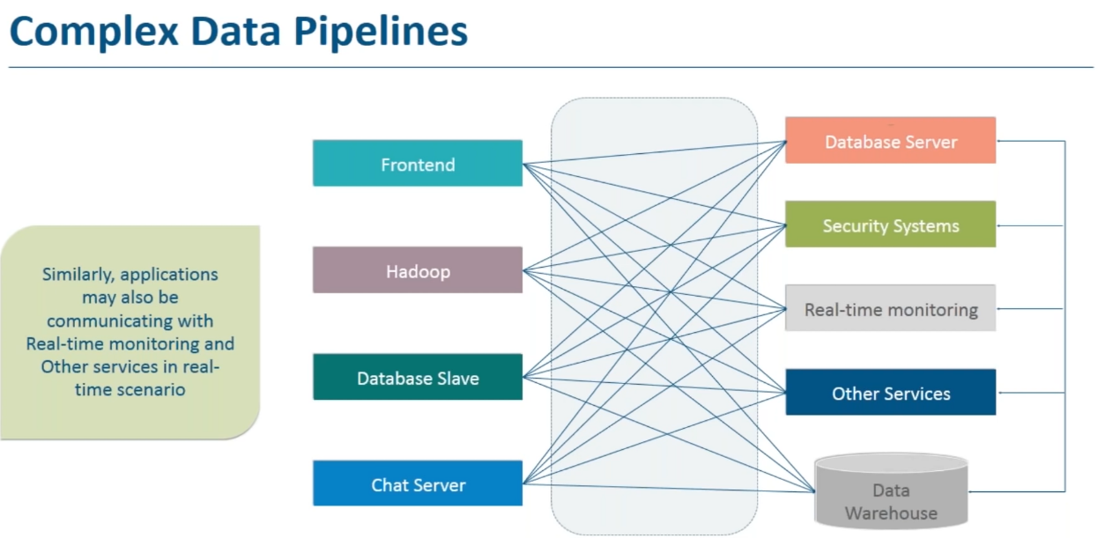

* So managing this data pipeline become very much difficult when new system and new servers are added in the infrastructure as each data pipe line will have its own requirement.
* For example, data pipeline which handles transaction should be fault tolerant and robust.

Robust.

* So adding and removing data pipeline become very difficult.
* And that is the reason that messaging systems was originated

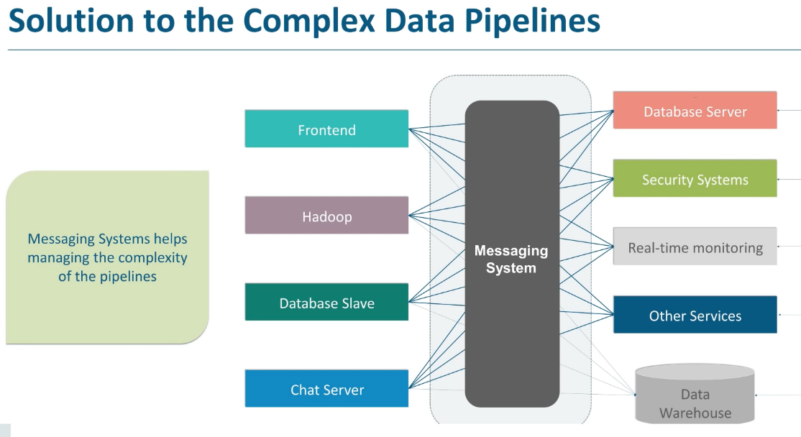

* So overall messaging system simplifies data pipe line management and makes communication between system easy and manageable.
* So using messaging system can easily establish a connection between remote system and Send the data easily across network.
* We can establish asynchronous communication and send messages so that sender do not have to wait the receiver to receive the message.

-----------------------------------X-----------------------------------------

**What is Kafka?**

**Ans-**

* Producer sends messages to Kafka and Kafka sends that messages to consumer.
* Consumer has to subscribe for receiving the messages.

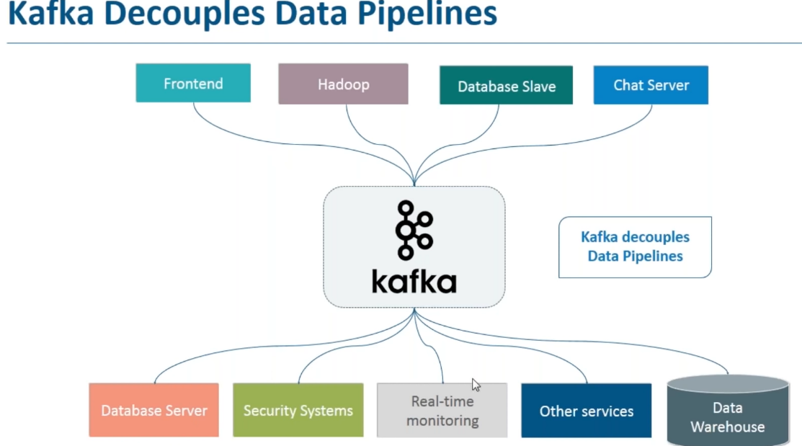

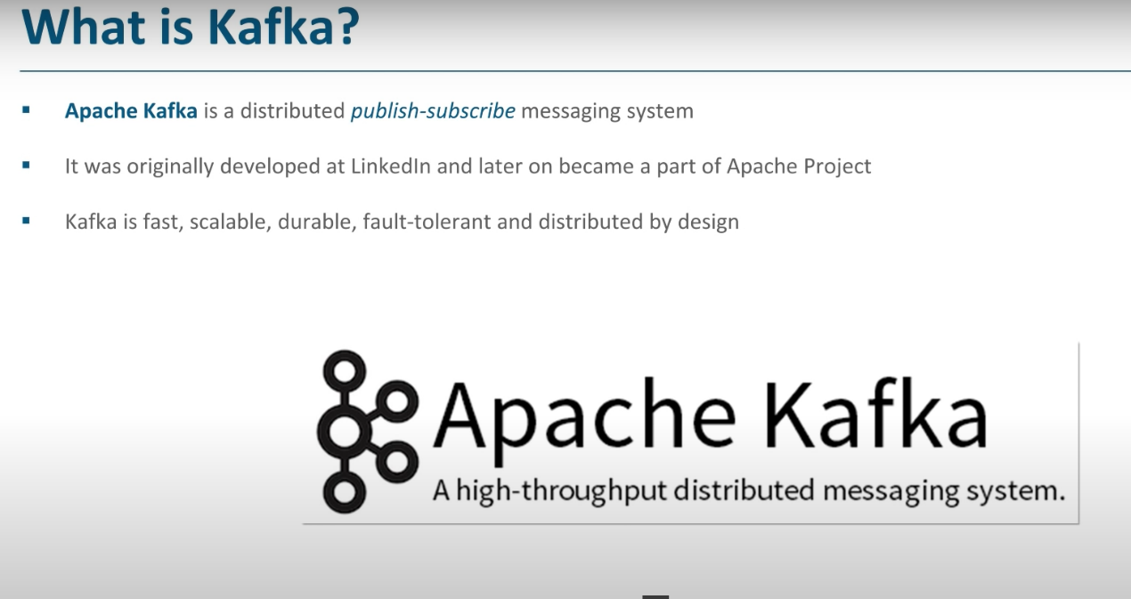

**-------------------------------------------------------X------------------------------------------**

**How many types of model are there for messaging?**

Ans –

There are 2 models-

-Queuing - In queue a pool of consumer may read from server and each record goes to one of them.

-Publish/subscribe model. – But in this model record is broadcasted to multiple consumer and consumer can read it.

----------------------------------X----------------------------------------------------------------

**What is high level view of Kafka and who uses it?**

**Ans-**

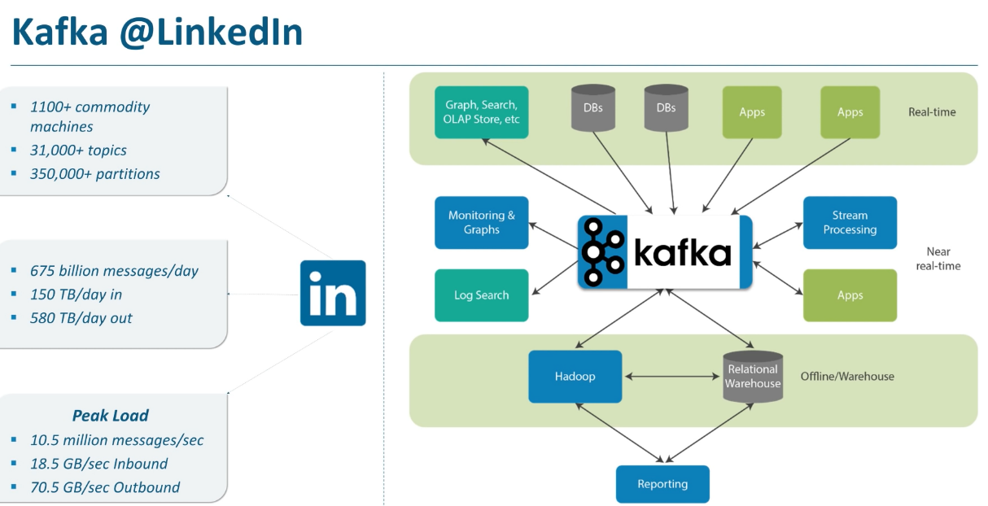

**------------------------------X------------------------------------------------------------**

**What are different building blocks of Kafka?**

**Ans-**

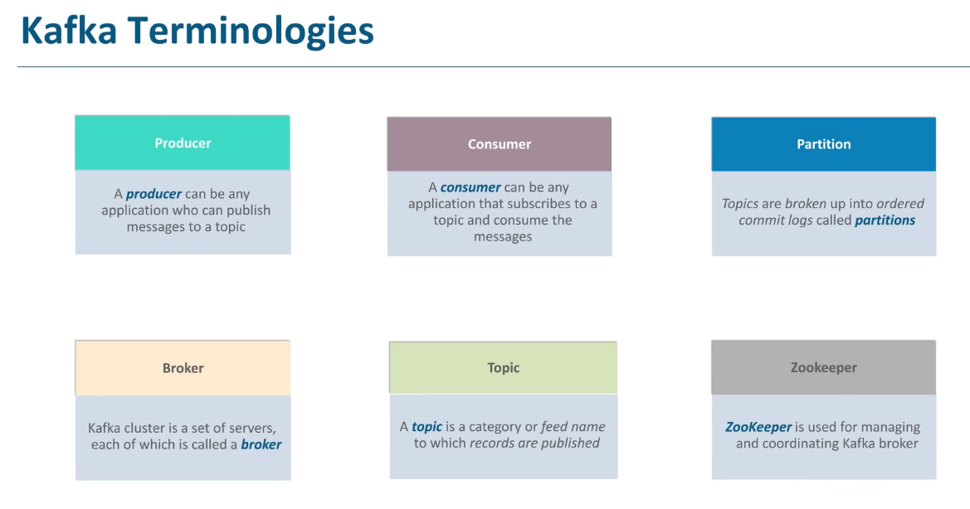

* Topics are multi subscriber. Means Sales system can produce messages to sales topics. Product system can produce messages to product topics and anybody who subscribe to corresponding topics can be consumed from it.
* Kafka topics can be divided into no of partitions.
* Partitions allow you to parallelize the topics by spiting the data in a particular topic across multiple broker.
* Each participant can be placed on multiple machine to allow multiple consumer to read from a topics parallel.
* Ex Sales application sales topics can have 3 partition so that 3 consumers can consume the data parallel.
* Consumers can be a part of consumer group.
* Brokers are single machine in the Kafka cluster.
* Zookeeper is another apache Kafka project which stores metadata information about Kafka cluster like broker information and topics details.

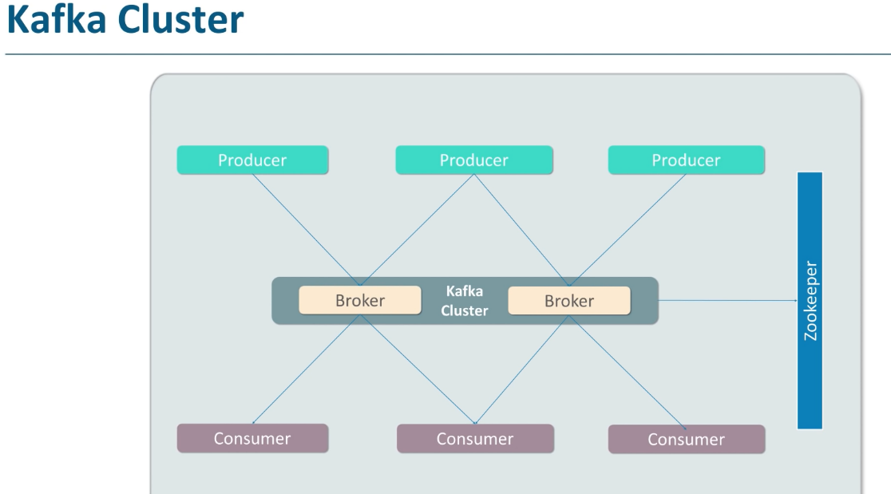

**-------------------------------X-------------------------------------------------------**

**Explain Kafka Features.**

**Ans-**

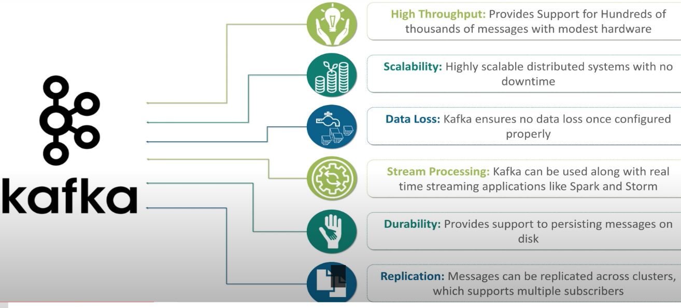

* High Throughput- No of messages produced and consumed in the given time
* Scalability - scale up and scale up the kaka cluster.
* Data Loss- With proper configuration Kafka ensures no data loss.
* Stream Processing – It takes continues stream of data from input topics and produce continuous stream of data to output stream. It provides full integrated stream api
* Replication

**---------------------------------------------X--------------------------------------------------------------**

**Explain something about topics and partitions in Kafka?**

Ans-

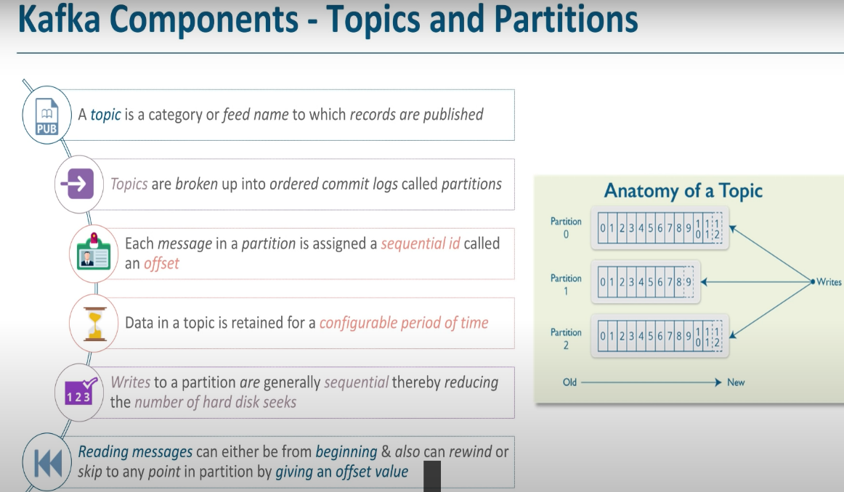

* Kafka clusters maintain the records for minimum 7 days.
* While consuming data consumer can specify, topics, partition no and offset value to read the data
* Consumer can even reset the offset and read from anywhere they want.

**------------------------------------------X------------------------------------------------------------------**

**What is replica and how does it work?**

Ans-

* Leader is requiring in case leader replica fails then another replica from another broker become the leader.

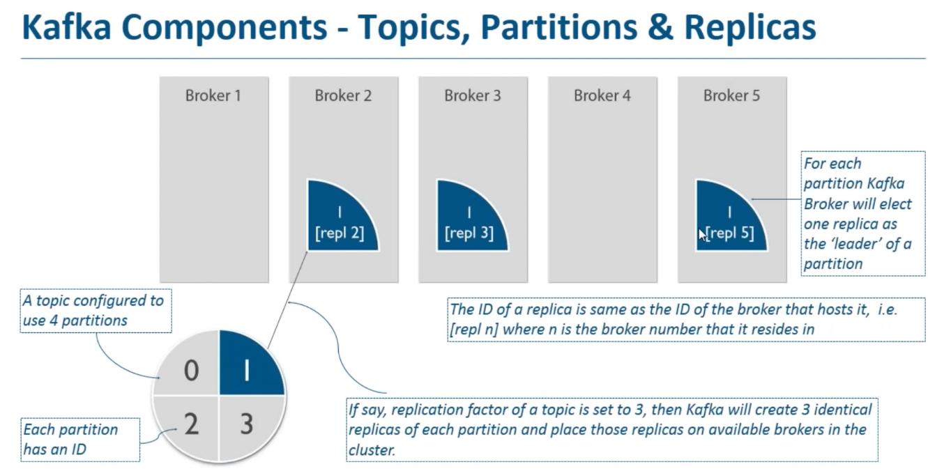

**--------------------------------------X--------------------------------------------------------------------------------**

**What is Kafka Message?**

**Ans-**

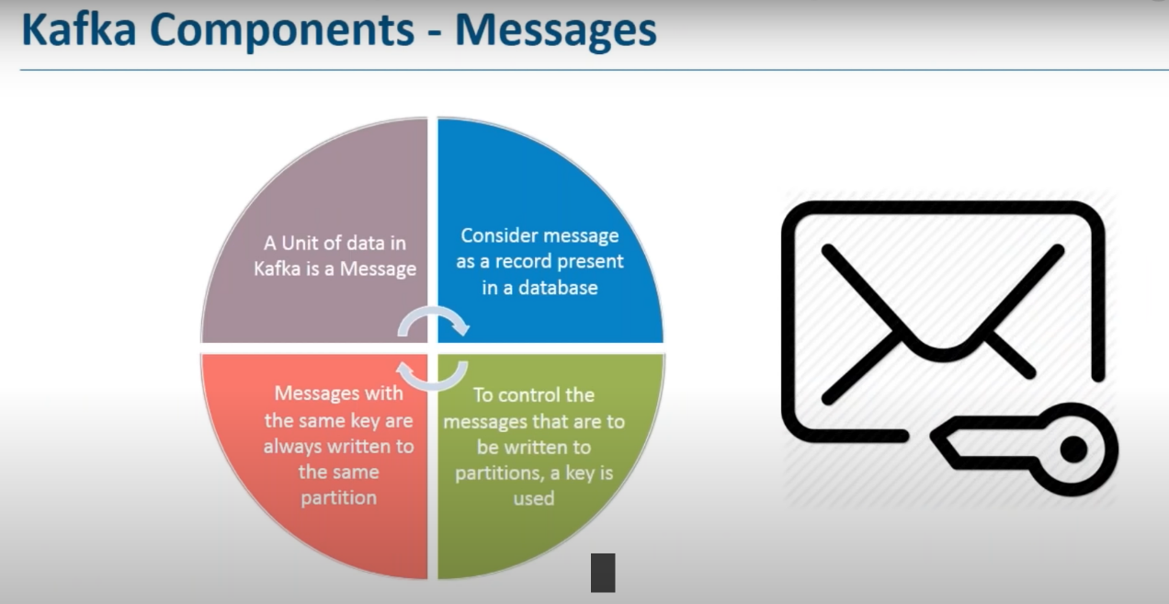

* Kafka messages will always have Key –Value- Timestamp associated with it.
* Message with the same key is always written in the same partition
* We can create some set of messages with key sales.
* Another set of messages with key products and third set of messages with the name marketing. So that data goes to the corresponding set of partition.

**-----------------------------------X-------------------------------------------------**

**What is Kafka producer and consumer?**

Ans-

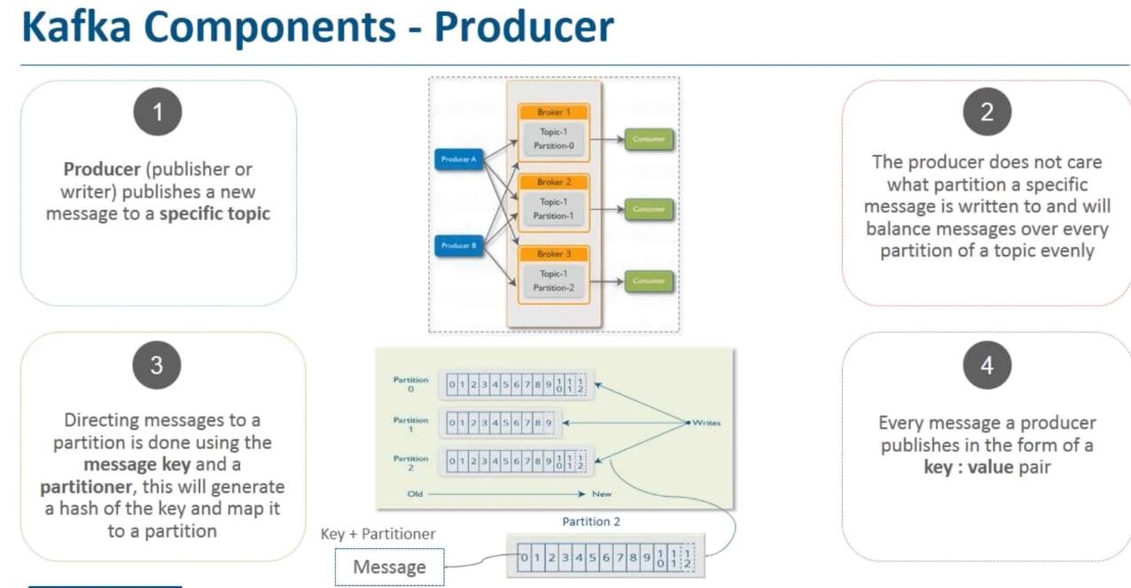

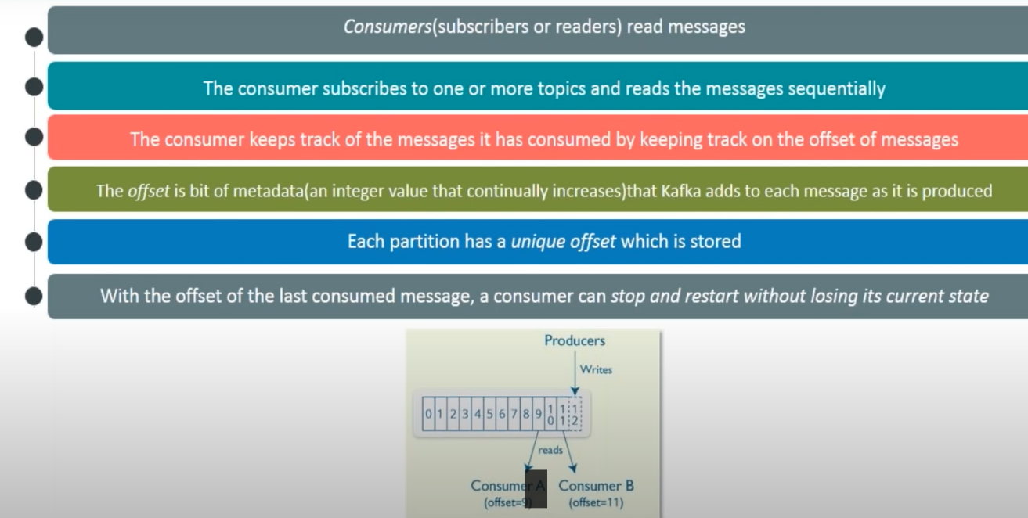

----------------------------------------X--------------------------------------------------------------

**What is Zookeeper?**

Ans-

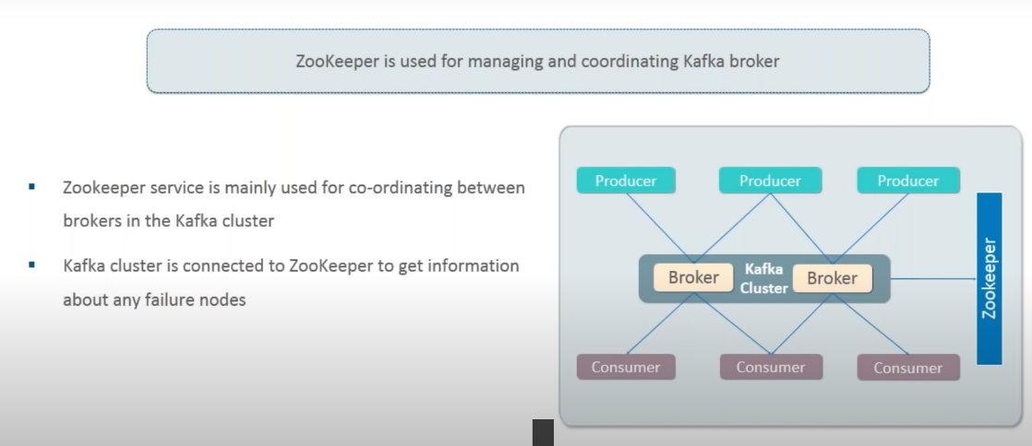

----------------------------X-----------------------------------------------------------------------------

**Explain Kafka Architecture**

Ans-

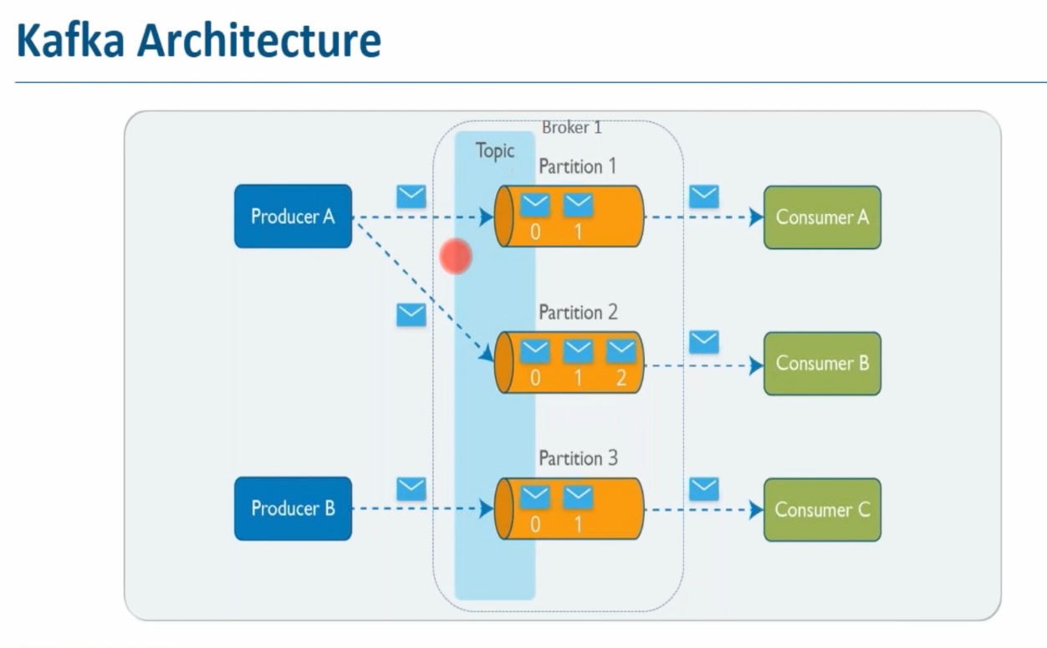

-----------------------------------------X-----------------------------------------------------------------------

**Kafka Use Case**

Ans-

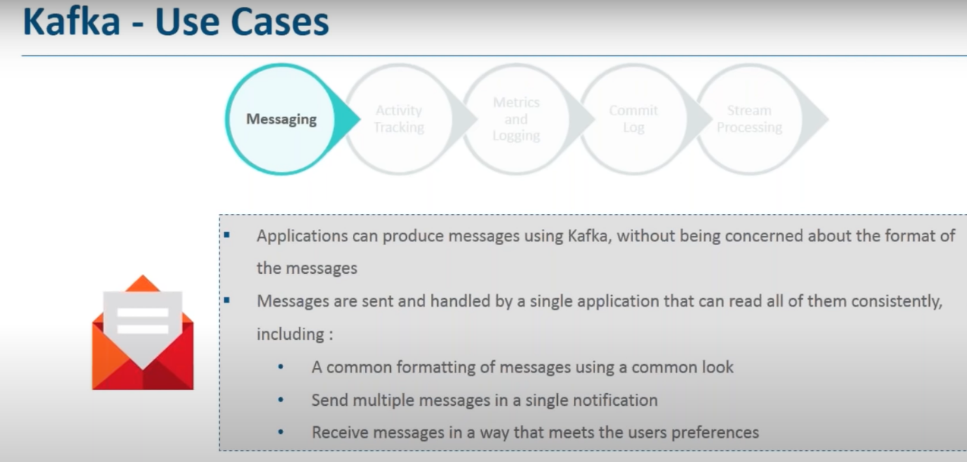

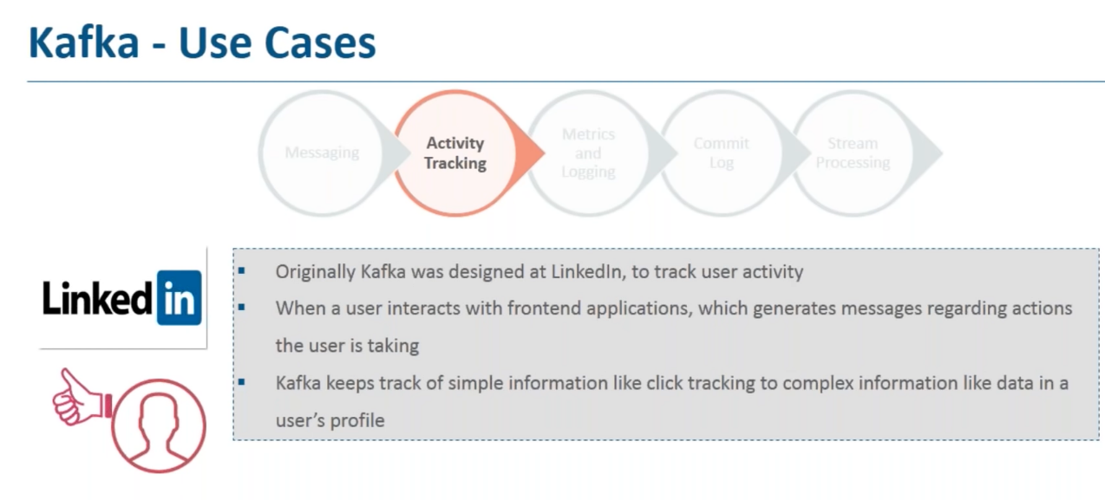

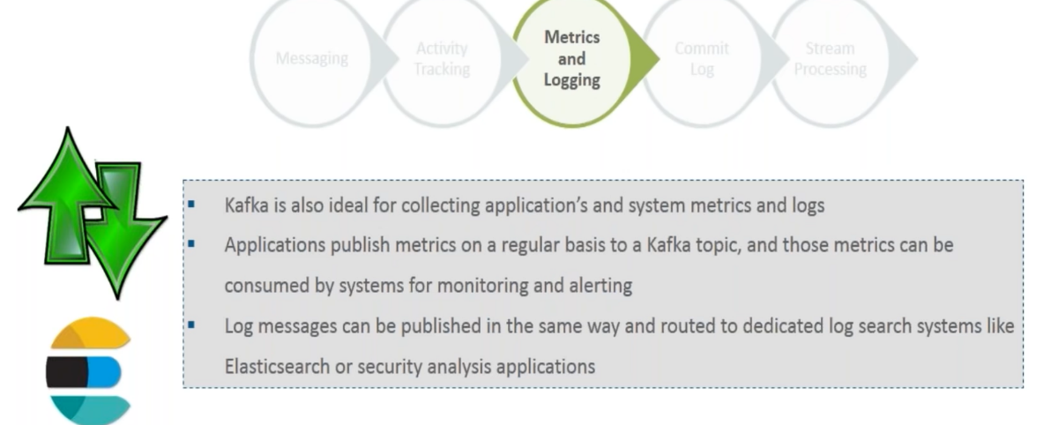

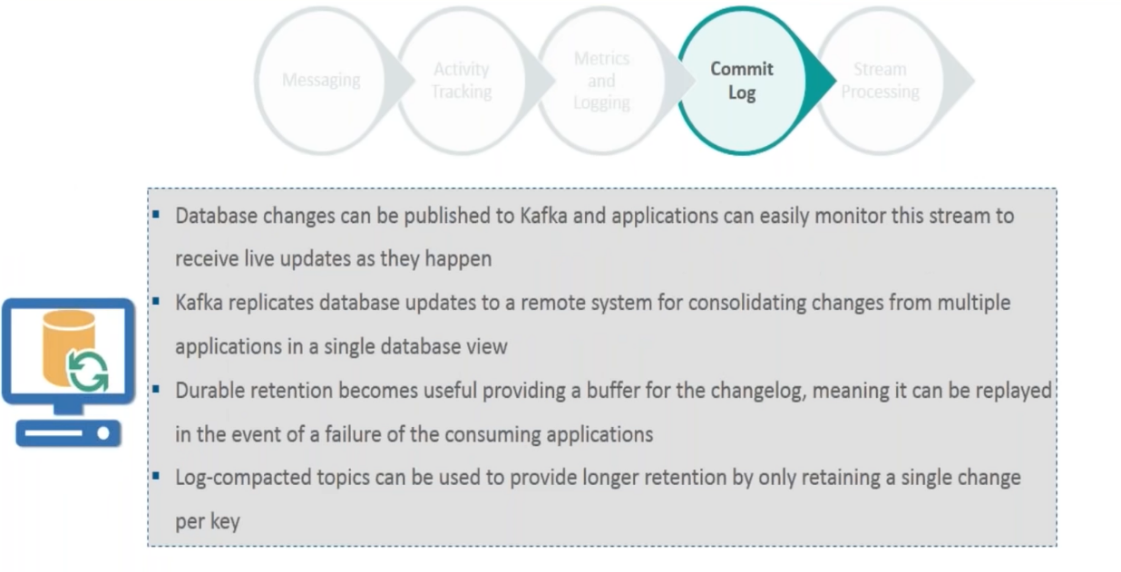

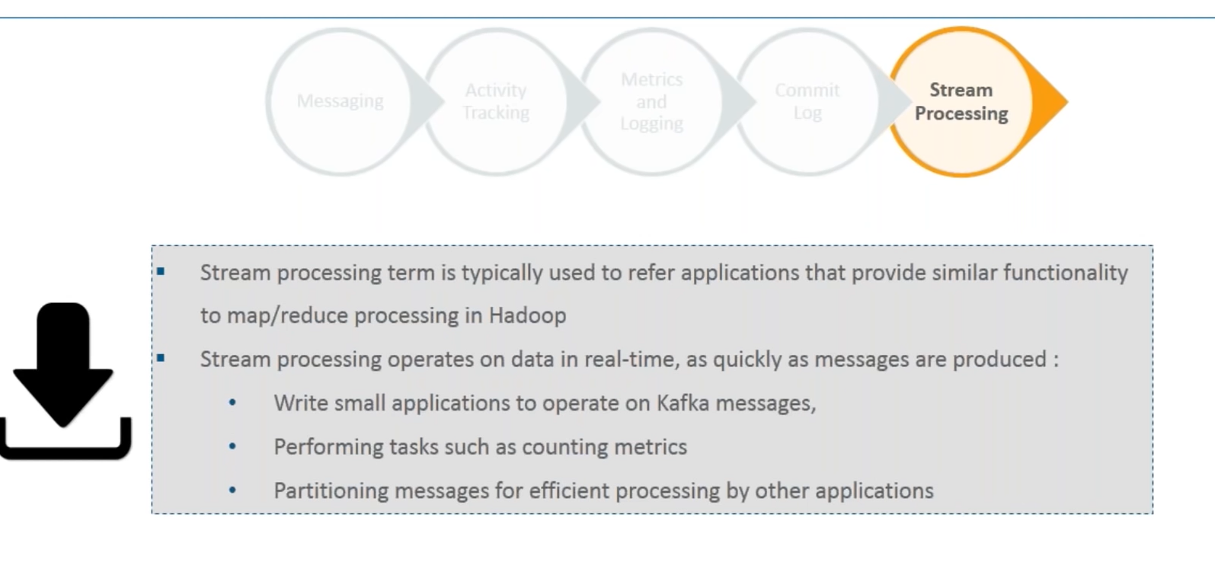

**----------------------------------------------X-----------------------------------------------------------------------**

**What are types of Kafka Cluster?**

**Ans-**

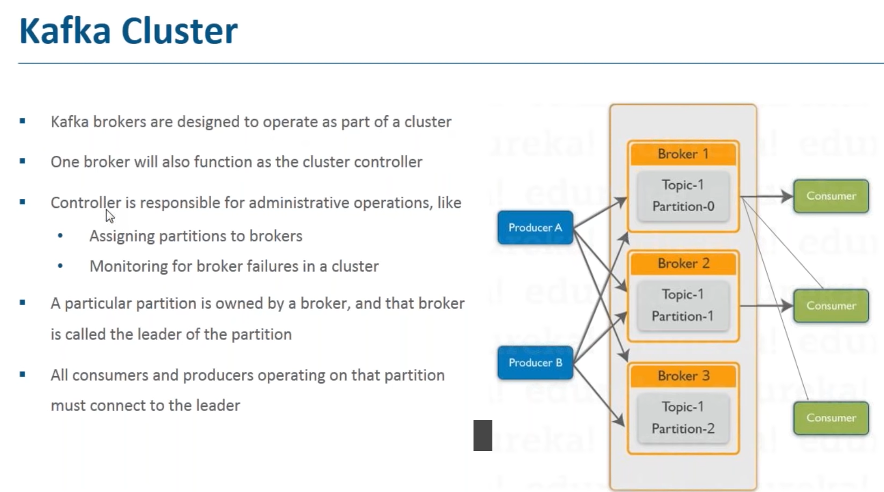

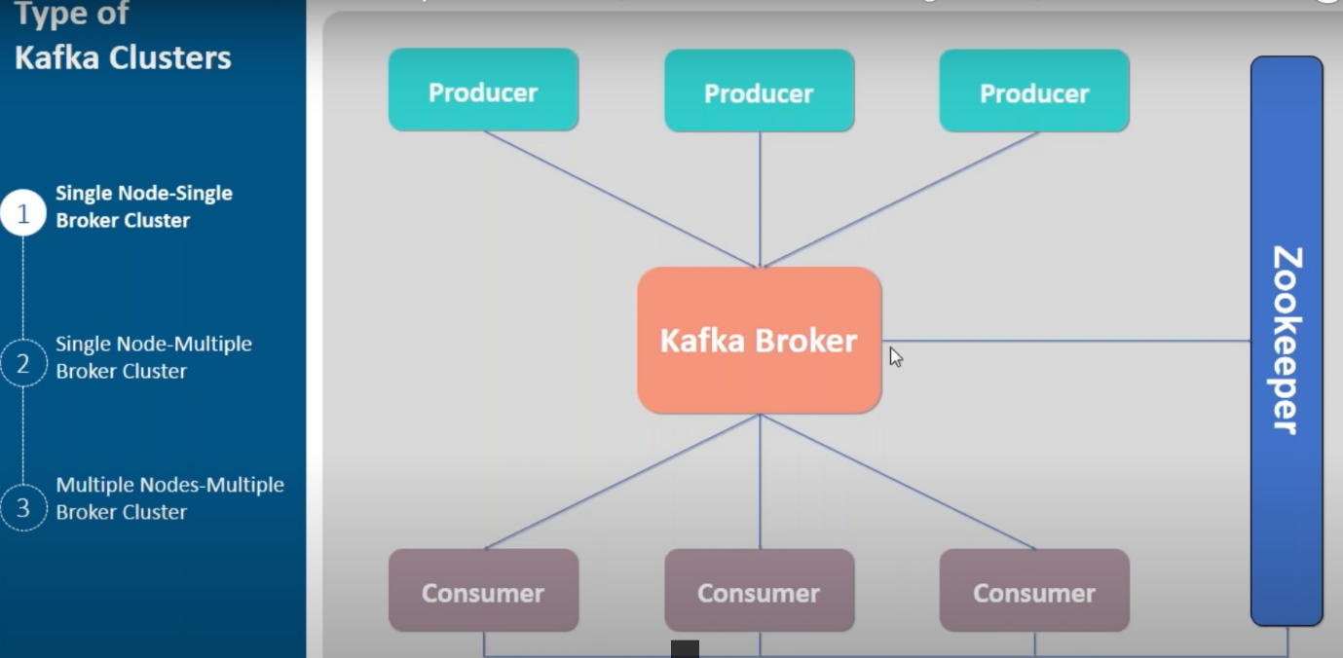

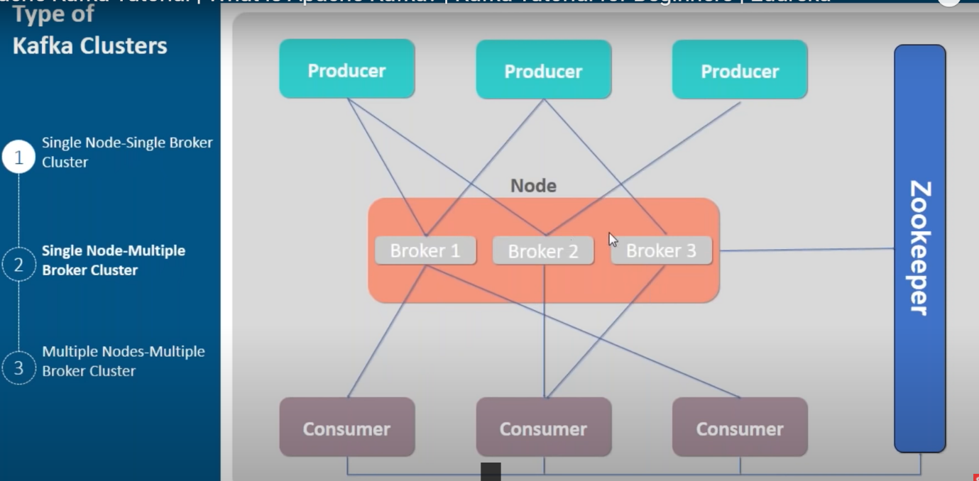

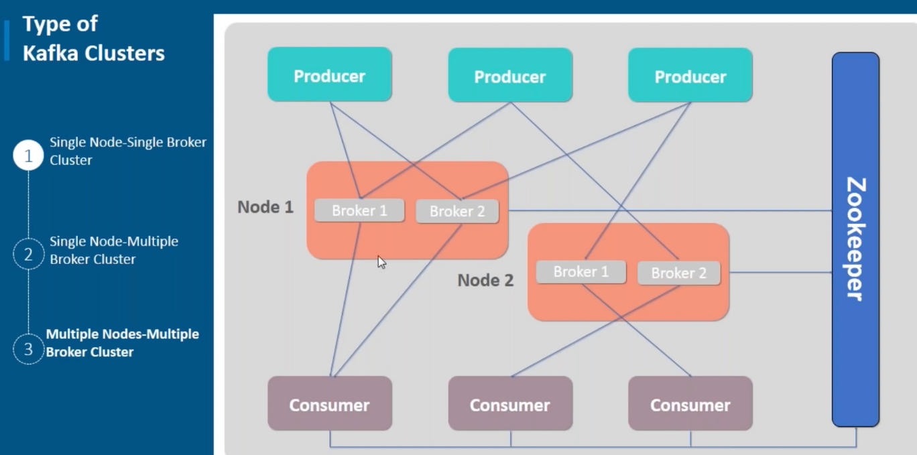

**--------------------------------------------------------X-------------------------------------------**

**What is consumer groups?**

**Ans-**

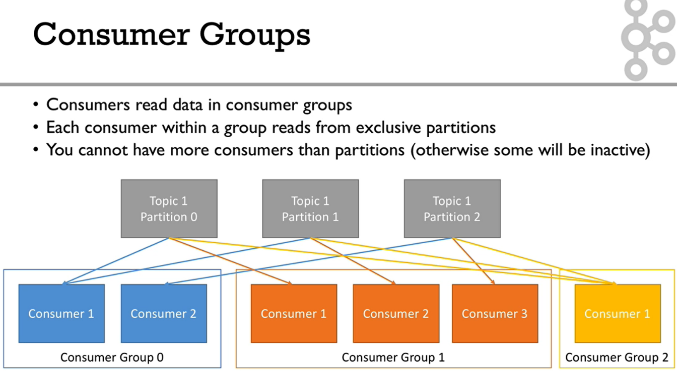

**------------------------------------------------------------X----------------------------------------------------**

**What is consumer Offset?**

**Ans-**

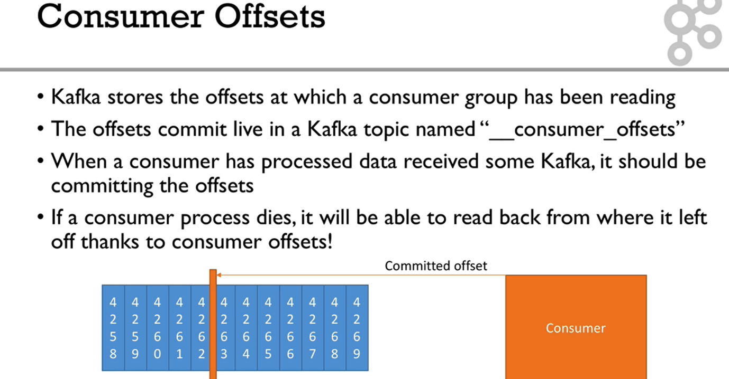

**------------------------------------X----------------------------------------------------------------------**

**List consumer groups command**

**And**

* **C:\kafka> .\bin\windows\kafka-consumer-groups.bat --bootstrap-server localhost:9092 –list**
* **C:\kafka>.\bin\windows\kafka-consumer-groups.bat --bootstrap-server localhost:9092 -describe -group vaishaligroup1**
* If u stop consumer and producer produce message and consumer lags with message as follows.

**C:\kafka>.\bin\windows\kafka-consumer-groups.bat --bootstrap-server localhost:9092 -describe -group vaishaligroup1**

Consumer group 'vaishaligroup1' has no active members.

GROUP TOPIC PARTITION CURRENT-OFFSET LOG-END-OFFSET LAG CONSUMER-ID HOST CLIENT-ID

vaishaligroup MovieTopic 1 9 11 2 - - -

vaishaligroup MovieTopic 2 2 3 1 - - -

vaishaligroup MovieTopic 0 9 9 0 - - -

-------------------------------------------------X--------------------------------------------------------------

Stop the vaishaligroup1 consumer and run following command

**C:\kafka> .\bin\windows\kafka-consumer-groups.bat --bootstrap-server localhost:9092 --group vaishaligroup1 --reset-offsets --to-earliest --execute --topic MovieTopic**

GROUP TOPIC PARTITION NEW-OFFSET

vaishaligroup MovieTopic 0 0

vaishaligroup MovieTopic 1 0

vaishaligroup MovieTopic 2 0

------------------------------------------X--------------------------------------------

Not let producer produce message as follows.

C:\kafka>.\bin\windows\kafka-console-producer.bat --broker-list localhost:9092 -topic MovieTopic

>hi

>hello

>g1

>g2

>g3

>g4

>g5

>g6

>hi

>hi

>group-1 activw

>deactivated

>group-1 deactivated

-------------------------------------X-------------------------------

**C:\kafka>.\bin\windows\kafka-consumer-groups.bat --bootstrap-server localhost:9092 --group vaishaligroup1 --describe**

Consumer group 'vaishaligroup1' has no active members.

GROUP TOPIC PARTITION CURRENT-OFFSET LOG-END-OFFSET LAG CONSUMER-ID HOST CLIENT-ID

vaishaligroup1 MovieTopic 1 0 4 4 - - -

vaishaligroup1 MovieTopic 2 0 5 5 - - -

vaishaligroup1 MovieTopic 0 0 4 4 - -

------------------------------X-------------------------------------

**Start consumer now**

**C:\kafka>.\bin\windows\kafka-console-consumer.bat --bootstrap-server localhost:9092 --topic MovieTopic --from-beginning --group vaishaligroup1**

g3

g5

hi

hi

hi

g1

g4

group-1 activw

group-1 deactivated

hello

g2

g6

deactivated

----------------------------------------X------------------------

**C:\kafka>.\bin\windows\kafka-consumer-groups.bat --bootstrap-server localhost:9092 --group vaishaligroup1 --describe**

GROUP TOPIC PARTITION CURRENT-OFFSET LOG-END-OFFSET LAG CONSUMER-ID HOST CLIENT-ID

vaishaligroup1 MovieTopic 0 4 4 0 consumer-vaishaligroup1-1-d2ad96a2-6792-4a8c-8643-cbf42a787f52 /192.168.1.6 consumer-vaishaligroup1-1

vaishaligroup1 MovieTopic 1 4 4 0 consumer-vaishaligroup1-1-d2ad96a2-6792-4a8c-8643-cbf42a787f52 /192.168.1.6 consumer-vaishaligroup1-1

vaishaligroup1 MovieTopic 2 5 5 0 consumer-vaishaligroup1-1-d2ad96a2-6792-4a8c-8643-cbf42a787f52 /192.168.1.6 consumer-vaishaligroup1-1

**-------------------------X-----------------------------**

**Now again stop consumer**

C:\kafka>.\bin\windows\kafka-consumer-groups.bat --bootstrap-server localhost:9092 --group vaishaligroup1 --reset-offsets --shift-by 2 --execute --topic MovieTopic

[2021-07-30 21:15:36,922] WARN New offset (6) is higher than latest offset for topic partition MovieTopic-0. Value will be set to 4 (kafka.admin.ConsumerGroupCommand$)

[2021-07-30 21:15:36,923] WARN New offset (6) is higher than latest offset for topic partition MovieTopic-1. Value will be set to 4 (kafka.admin.ConsumerGroupCommand$)

[2021-07-30 21:15:36,924] WARN New offset (7) is higher than latest offset for topic partition MovieTopic-2. Value will be set to 5 (kafka.admin.ConsumerGroupCommand$)

GROUP TOPIC PARTITION NEW-OFFSET

vaishaligroup1 MovieTopic 0 4

vaishaligroup1 MovieTopic 1 4

vaishaligroup1 MovieTopic 2 5

------------------------------------------X------------------------------

**Now start consumer**

And run following command

**C:\kafka>.\bin\windows\kafka-consumer-groups.bat --bootstrap-server localhost:9092 --group vaishaligroup1 --reset-offsets --shift-by -2 --execute --topic MovieTopic**

GROUP TOPIC PARTITION NEW-OFFSET

vaishaligroup1 MovieTopic 0 3

vaishaligroup1 MovieTopic 1 3

vaishaligroup1 MovieTopic 2 3

--------------------------------X---------------------------------

**C:\kafka>.\bin\windows\kafka-console-consumer.bat --bootstrap-server localhost:9092 --topic MovieTopic --from-beginning --group vaishaligroup1**

hi

started 1

group-1 activw

group-1 deactivated

deactivated

strted 2

**--------------------------X-------------------------------------------------------------**

**Start Producer Console using Key Value**

**C:\kafka>.\bin\windows\kafka-console-producer --broker-list 127.0.0.1:9092 --topic MovieTopic --property parse.key=true --property key.separator=,**

>1,hi

>2,hello

>3,vaishali

-------------------------------X-------------------------------------------

**What is Kafka Polling?**

Ans-

**--------------------------------------Java Demo-------------------------------**

**------------------------------Testproducer.java-------------------------------------**

package com.cg.kafka;

import org.apache.kafka.clients.producer.KafkaProducer;

import org.apache.kafka.clients.producer.ProducerConfig;

import org.apache.kafka.clients.producer.ProducerRecord;

import org.apache.kafka.common.serialization.StringSerializer;

import java.util.Properties;

public class TestProducerDemo {

public static void main(String[] args)

{

System.out.print("producer started");

String bootstrapServers = "127.0.0.1:9092";

// create Producer properties

Properties properties = new Properties();

properties.setProperty(ProducerConfig.BOOTSTRAP_SERVERS_CONFIG, bootstrapServers);

properties.setProperty(ProducerConfig.KEY_SERIALIZER_CLASS_CONFIG, StringSerializer.class.getName());

properties.setProperty(ProducerConfig.VALUE_SERIALIZER_CLASS_CONFIG, StringSerializer.class.getName());

// create the producer

KafkaProducer<String, String> producer = new KafkaProducer<String, String>(properties);

// create a producer record

ProducerRecord<String, String> record =

new ProducerRecord<String, String>("MovieTopic", "hello world");

// send data - asynchronous

producer.send(record);

// flush data

producer.flush();

// flush and close producer

producer.close();

}}

**--------------------------ProducerDemoWithCallback.java---------------------------**

package com.cg.kafka;

import org.apache.kafka.clients.producer.*;

import org.apache.kafka.common.serialization.StringSerializer;

import org.slf4j.Logger;

import org.slf4j.LoggerFactory;

import java.util.Properties;

public class ProducerDemoWithCallback {

public static void main(String[] args) {

final Logger logger = LoggerFactory.getLogger(ProducerDemoWithCallback.class);

String bootstrapServers = "127.0.0.1:9092";

// create Producer properties

Properties properties = new Properties();

properties.setProperty(ProducerConfig.BOOTSTRAP_SERVERS_CONFIG, bootstrapServers);

properties.setProperty(ProducerConfig.KEY_SERIALIZER_CLASS_CONFIG, StringSerializer.class.getName());

properties.setProperty(ProducerConfig.VALUE_SERIALIZER_CLASS_CONFIG, StringSerializer.class.getName());

// create the producer

KafkaProducer<String, String> producer = new KafkaProducer<String, String>(properties);

for (int i=0; i<10; i++ )

{

// create a producer record

ProducerRecord<String, String> record =

new ProducerRecord<String, String>("MovieTopic", "hello world callback " + Integer.toString(i));

// send data - asynchronous

//oncompletion function called every time record being send

producer.send(record, new Callback()

{

public void onCompletion(RecordMetadata recordMetadata, Exception e) {

// executes every time a record is successfully sent or an exception is thrown

if (e == null)

{

// the record was successfully sent

logger.info("Received new metadata. \n" +

"Topic:" + recordMetadata.topic() + "\n" +

"Partition: " + recordMetadata.partition() + "\n" +

"Offset: " + recordMetadata.offset() + "\n" +

"Timestamp: " + recordMetadata.timestamp());

}

else

{

logger.error("Error while producing", e);

}

}

});

}

// flush data

producer.flush();

// flush and close producer

producer.close();

}

}

**-----------------------------------------------ProducerDemoKey.java---------------------------**

package com.cg.kafka;

import org.apache.kafka.clients.producer.*;

import org.apache.kafka.common.serialization.StringSerializer;

import org.slf4j.Logger;

import org.slf4j.LoggerFactory;

import java.util.Properties;

import java.util.concurrent.ExecutionException;

public class ProducerDemoKeys {

public static void main(String[] args) throws ExecutionException, InterruptedException {

final Logger logger = LoggerFactory.getLogger(ProducerDemoKeys.class);

String bootstrapServers = "127.0.0.1:9092";

// create Producer properties

Properties properties = new Properties();

properties.setProperty(ProducerConfig.BOOTSTRAP_SERVERS_CONFIG, bootstrapServers);

properties.setProperty(ProducerConfig.KEY_SERIALIZER_CLASS_CONFIG, StringSerializer.class.getName());

properties.setProperty(ProducerConfig.VALUE_SERIALIZER_CLASS_CONFIG, StringSerializer.class.getName());

// create the producer

KafkaProducer<String, String> producer = new KafkaProducer<String, String>(properties);

for (int i=0; i<10; i++ ) {

// create a producer record

String topic = "MovieTopic";

String value = "hello world key " + Integer.toString(i);

String key = "id_" + Integer.toString(i);

ProducerRecord<String, String> record =

new ProducerRecord<String, String>(topic, key, value);

logger.info("Key: " + key); // log the key

// id_0 is going to partition 1

// id_1 partition 0

// id_2 partition 2

// id_3 partition 0

// id_4 partition 2

// id_5 partition 2

// id_6 partition 0

// id_7 partition 2

// id_8 partition 1

// id_9 partition 2

// send data - asynchronous

producer.send(record, new Callback() {

public void onCompletion(RecordMetadata recordMetadata, Exception e) {

// executes every time a record is successfully sent or an exception is thrown

if (e == null) {

// the record was successfully sent

logger.info("Received new metadata. \n" +

"Topic:" + recordMetadata.topic() + "\n" +

"Partition: " + recordMetadata.partition() + "\n" +

"Offset: " + recordMetadata.offset() + "\n" +

"Timestamp: " + recordMetadata.timestamp());

} else {

logger.error("Error while producing", e);

}

}

}).get(); // block the .send() to make it synchronous - don't do this in production!

}

// flush data

producer.flush();

// flush and close producer

producer.close();

}

}

**----------------------------ConsumerDemo.java---------------------------------------**

package com.cg.kafka;

import org.apache.kafka.clients.consumer.ConsumerConfig;

import org.apache.kafka.clients.consumer.ConsumerRecord;

import org.apache.kafka.clients.consumer.ConsumerRecords;

import org.apache.kafka.clients.consumer.KafkaConsumer;

import org.apache.kafka.common.serialization.StringDeserializer;

import org.slf4j.Logger;

import org.slf4j.LoggerFactory;

import java.time.Duration;

import java.util.Arrays;

import java.util.Properties;

public class ConsumerDemo {

public static void main(String[] args) {

Logger logger = LoggerFactory.getLogger(ConsumerDemo.class.getName());

String bootstrapServers = "127.0.0.1:9092";

String groupId = "my-fourth-application";

String topic = "MovieTopic";

// create consumer configs

Properties properties = new Properties();

properties.setProperty(ConsumerConfig.BOOTSTRAP_SERVERS_CONFIG, bootstrapServers);

properties.setProperty(ConsumerConfig.KEY_DESERIALIZER_CLASS_CONFIG, StringDeserializer.class.getName());

properties.setProperty(ConsumerConfig.VALUE_DESERIALIZER_CLASS_CONFIG, StringDeserializer.class.getName());

properties.setProperty(ConsumerConfig.GROUP_ID_CONFIG, groupId);

properties.setProperty(ConsumerConfig.AUTO_OFFSET_RESET_CONFIG, "earliest");

// create consumer

KafkaConsumer<String, String> consumer = new KafkaConsumer<String, String>(properties);

// subscribe consumer to our topic(s)

consumer.subscribe(Arrays.asList(topic));

//consumer will not get the data ulless it it ask for it

// poll for new data

while(true){

ConsumerRecords<String, String> records =

consumer.poll(Duration.ofMillis(100)); // new in Kafka 2.0.0

for (ConsumerRecord<String, String> record : records){

logger.info("Key: " + record.key() + ", Value: " + record.value());

logger.info("Partition: " + record.partition() + ", Offset:" + record.offset());

}

}

}

}

**-----------------------------ConsumerDemoGroup.java------------------------------**

package com.cg.kafka;

import org.apache.kafka.clients.consumer.ConsumerConfig;

import org.apache.kafka.clients.consumer.ConsumerRecord;

import org.apache.kafka.clients.consumer.ConsumerRecords;

import org.apache.kafka.clients.consumer.KafkaConsumer;

import org.apache.kafka.common.serialization.StringDeserializer;

import org.slf4j.Logger;

import org.slf4j.LoggerFactory;

import java.time.Duration;

import java.util.Arrays;

import java.util.Properties;

public class ConsumerDemoGroups {

public static void main(String[] args) {

Logger logger = LoggerFactory.getLogger(ConsumerDemoGroups.class.getName());

String bootstrapServers = "127.0.0.1:9092";

String groupId = "vaishaligroup2";

String topic = "MovieTopic";

// create consumer configs

Properties properties = new Properties();

properties.setProperty(ConsumerConfig.BOOTSTRAP_SERVERS_CONFIG, bootstrapServers);

properties.setProperty(ConsumerConfig.KEY_DESERIALIZER_CLASS_CONFIG, StringDeserializer.class.getName());

properties.setProperty(ConsumerConfig.VALUE_DESERIALIZER_CLASS_CONFIG, StringDeserializer.class.getName());

properties.setProperty(ConsumerConfig.GROUP_ID_CONFIG, groupId);

properties.setProperty(ConsumerConfig.AUTO_OFFSET_RESET_CONFIG, "earliest");

// create consumer

KafkaConsumer<String, String> consumer = new KafkaConsumer<String, String>(properties);

// subscribe consumer to our topic(s)

consumer.subscribe(Arrays.asList(topic));

// poll for new data

while(true){

ConsumerRecords<String, String> records =

consumer.poll(Duration.ofMillis(100)); // new in Kafka 2.0.0

for (ConsumerRecord<String, String> record : records){

logger.info("Key: " + record.key() + ", Value: " + record.value());

logger.info("Partition: " + record.partition() + ", Offset:" + record.offset());

}

}

}

}

**------------------------ConsumerDemoAssignSeek.java----------------------------**

package com.cg.kafka;

import org.apache.kafka.clients.consumer.ConsumerConfig;

import org.apache.kafka.clients.consumer.ConsumerRecord;

import org.apache.kafka.clients.consumer.ConsumerRecords;

import org.apache.kafka.clients.consumer.KafkaConsumer;

import org.apache.kafka.common.TopicPartition;

import org.apache.kafka.common.serialization.StringDeserializer;

import org.slf4j.Logger;

import org.slf4j.LoggerFactory;

import java.time.Duration;

import java.util.Arrays;

import java.util.Properties;

public class ConsumerDemoAssignSeek {

public static void main(String[] args) {

Logger logger = LoggerFactory.getLogger(ConsumerDemoAssignSeek.class.getName());

String bootstrapServers = "127.0.0.1:9092";

String topic = "MovieTopic";

// create consumer configs

Properties properties = new Properties();

properties.setProperty(ConsumerConfig.BOOTSTRAP_SERVERS_CONFIG, bootstrapServers);

properties.setProperty(ConsumerConfig.KEY_DESERIALIZER_CLASS_CONFIG, StringDeserializer.class.getName());

properties.setProperty(ConsumerConfig.VALUE_DESERIALIZER_CLASS_CONFIG, StringDeserializer.class.getName());

properties.setProperty(ConsumerConfig.AUTO_OFFSET_RESET_CONFIG, "earliest");

// create consumer

KafkaConsumer<String, String> consumer = new KafkaConsumer<String, String>(properties);

// assign and seek are mostly used to replay data or fetch a specific message

// assign

TopicPartition partitionToReadFrom = new TopicPartition(topic, 0);

long offsetToReadFrom = 15L;

consumer.assign(Arrays.asList(partitionToReadFrom));

// seek

consumer.seek(partitionToReadFrom, offsetToReadFrom);

int numberOfMessagesToRead = 5;

boolean keepOnReading = true;

int numberOfMessagesReadSoFar = 0;

// poll for new data

while(keepOnReading){

ConsumerRecords<String, String> records =

consumer.poll(Duration.ofMillis(100)); // new in Kafka 2.0.0

for (ConsumerRecord<String, String> record : records){

numberOfMessagesReadSoFar += 1;

logger.info("Key: " + record.key() + ", Value: " + record.value());

logger.info("Partition: " + record.partition() + ", Offset:" + record.offset());

if (numberOfMessagesReadSoFar >= numberOfMessagesToRead){

keepOnReading = false; // to exit the while loop

break; // to exit the for loop

}

}

}

logger.info("Exiting the application");

}

}

**--------------------------Extra Topic In Kafka-------------------------------------------------------**

**What is Stream?**

**Ans-**

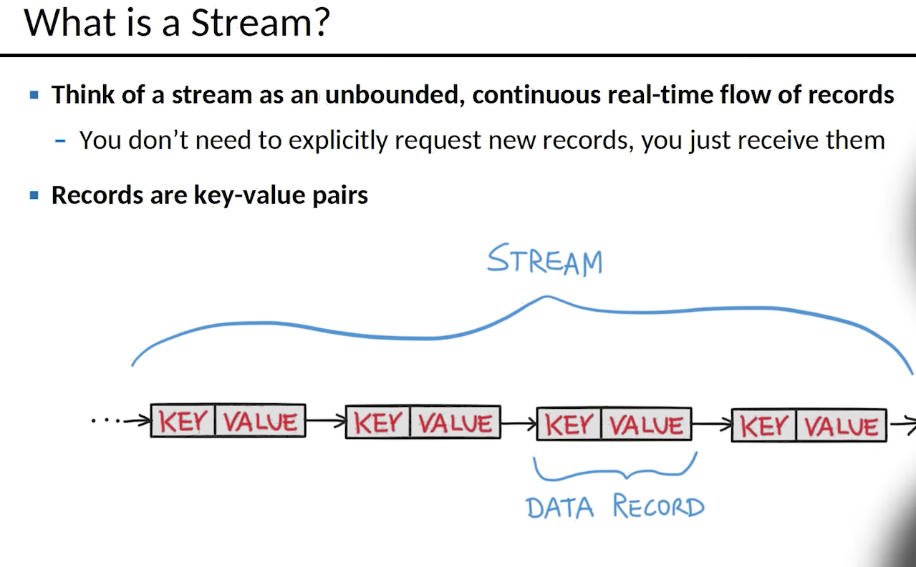

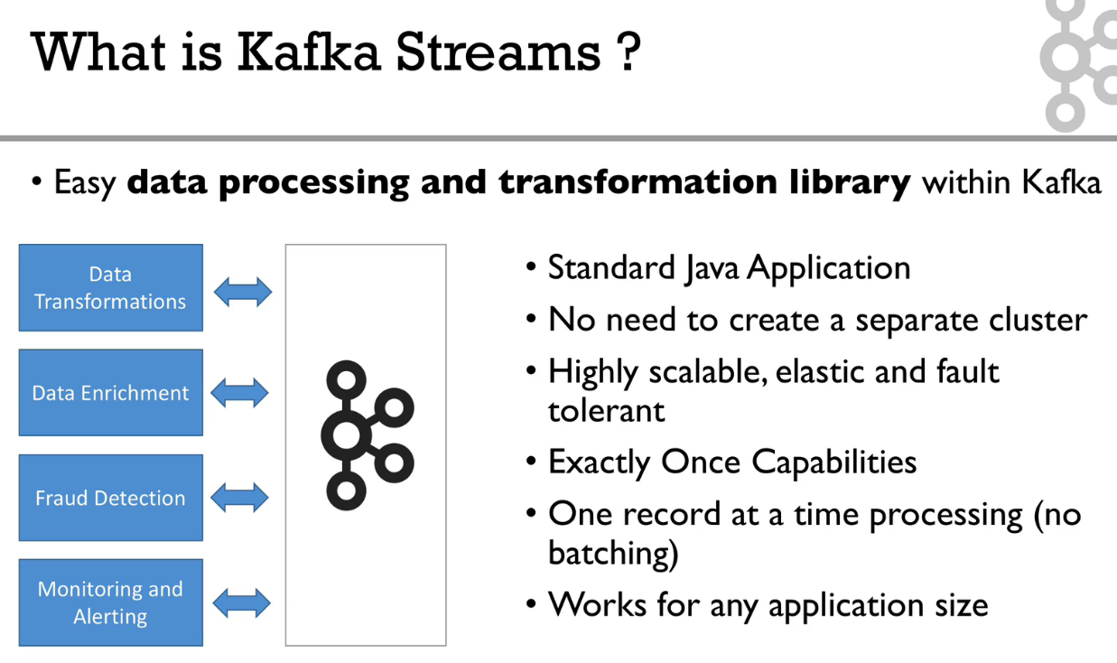

**---------------------------------X----------------------------------------------------**

**Explain about Kafka Stream architecture?**

**Ans-**

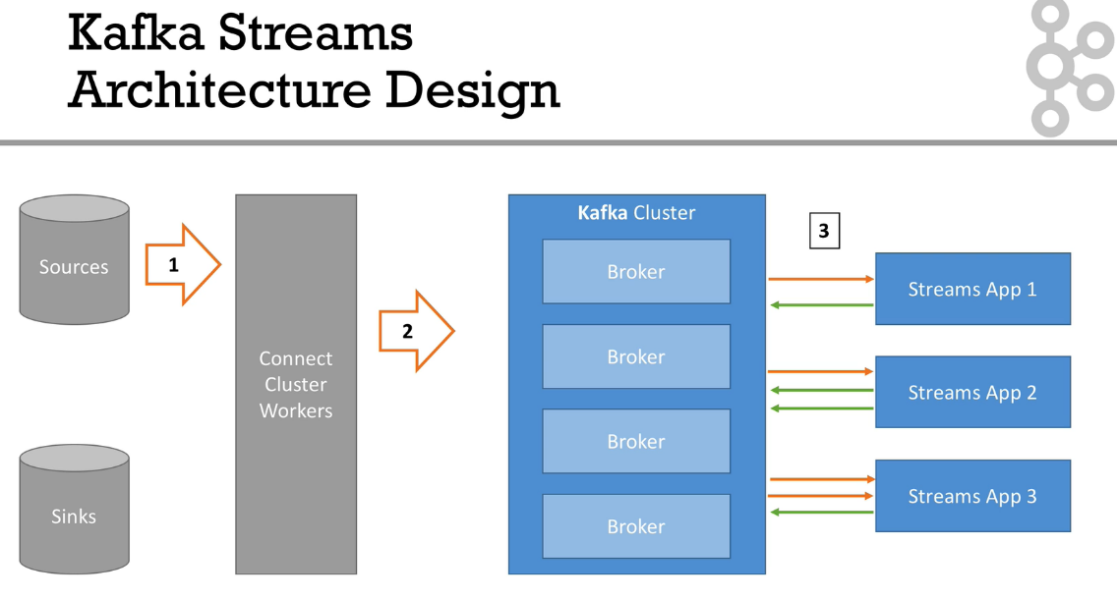

**-----------------------------------------X------------------------------------------------**

**What is Kafka Stream API?**

**Ans-**

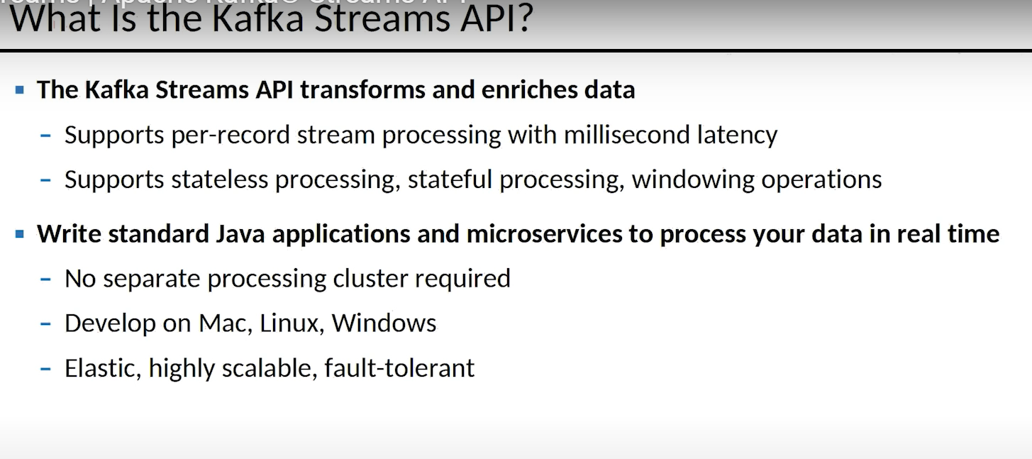

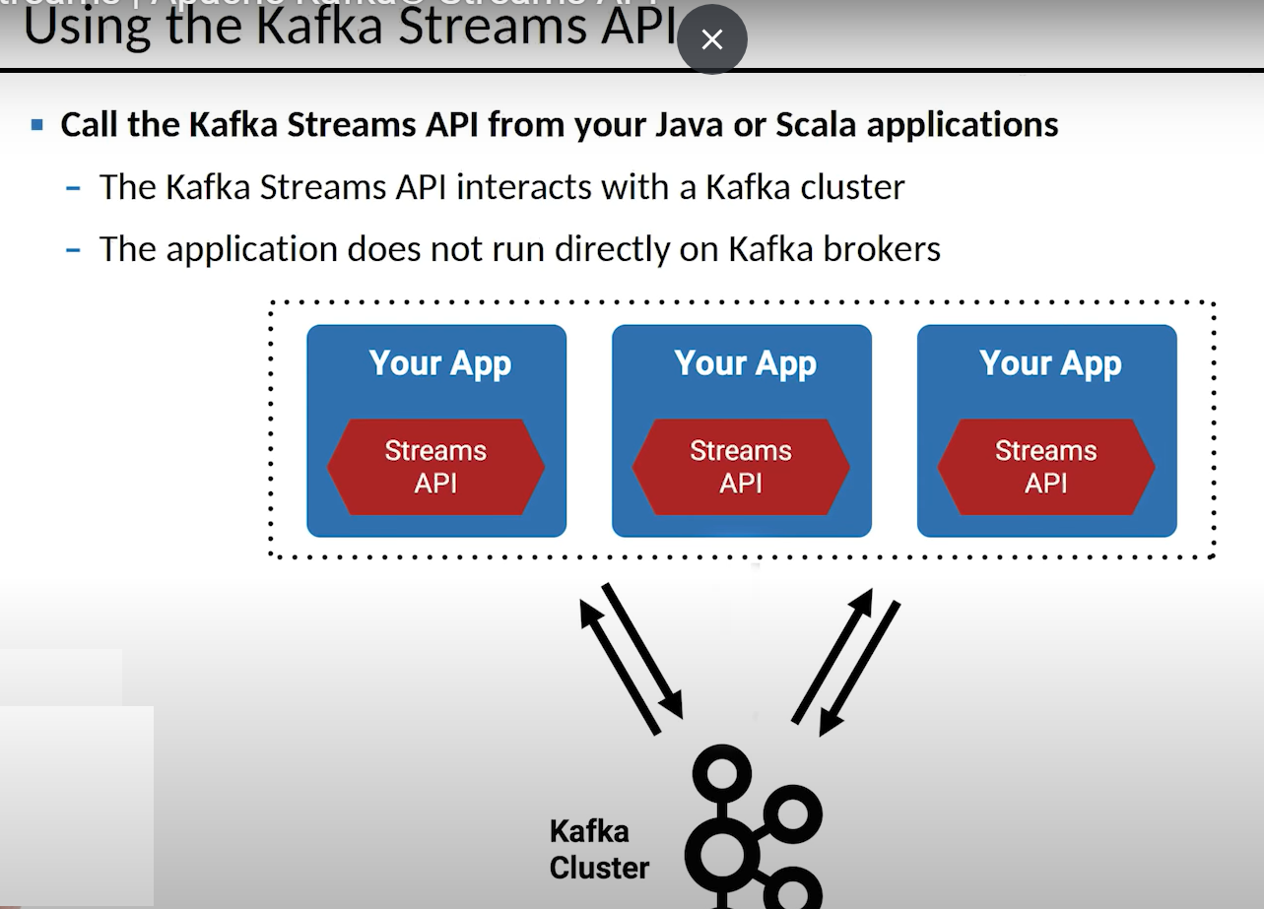

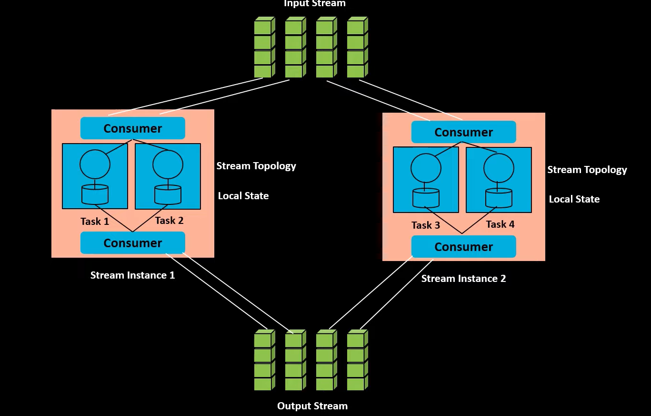

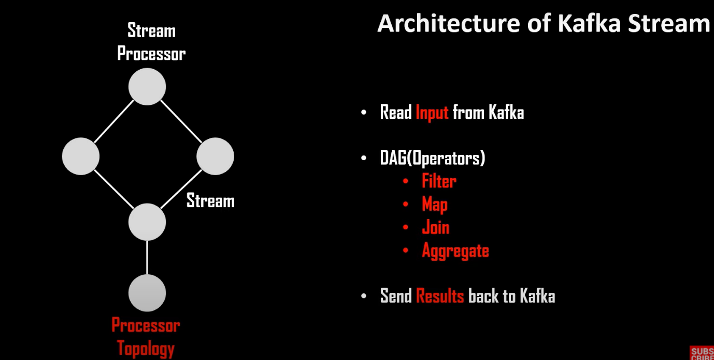

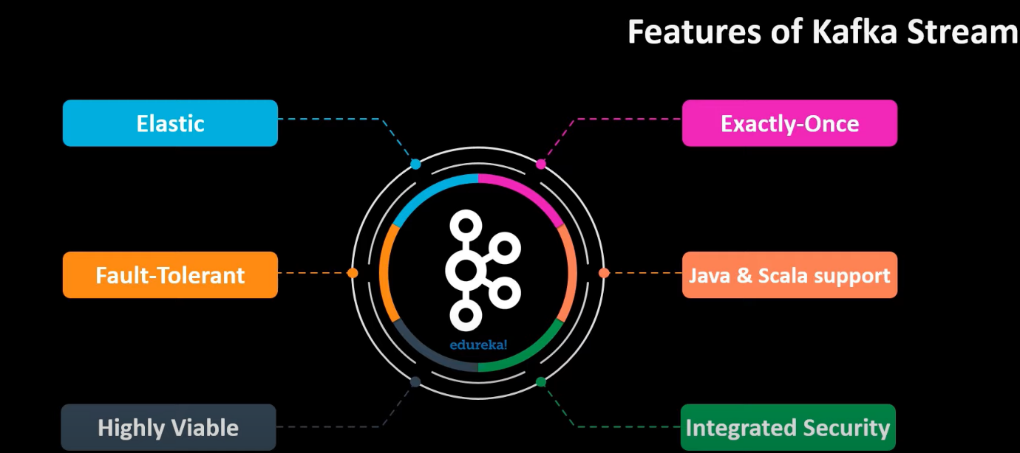

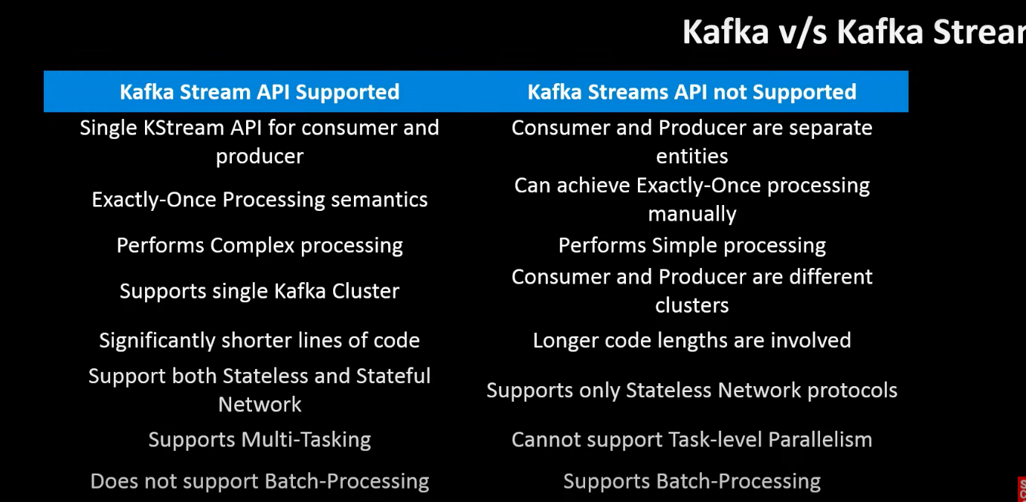

**------------------------------------------------Demo On Kafka Stream-------------------------------------------**

